**Visualization**

**Developer Manual**

Cady Pridgeon

Amee Kivette

Keanna Tennyson

Laura Wilson

### 

#### **COMP 4710 Senior Design Project #3 Team Orange**

Department of Computer Science and Software Engineering

Samuel Ginn College of Engineering, Auburn University

April 26, 2024

**Table of Contents**

**1. Introduction 3**

1.1. Project Overview 3

1.2. Project Mission 3

**2. Design Documentation 3**

2.1. Architecture 3

2.2. Structure 5

2.3. Interfaces 9

2.4. Justifications of Decisions 15

2.5. Assumptions & Dependencies 15

**3. Setup 16**

3.1. Omeka Classic 16

3.2. GitHub 16

**4. Testing 17**

4.1. Testing Plan 17

4.2. Test Cases & Results 17

**5. Deployment 17**

5.1. Omeka Classic 17

5.2. GitHub Pages 19

**6. Version History 19**

6.1. Neatline 19

6.2. D3.js 20

**References 23**

# **Introduction**

## **Project Overview**

The Alabama Authors of the 19th and 20th Centuries is a digital humanities project created by Dr. Beverley Park Rilett. This online resource provides access to information about Alabama authors and their published literature. Over a semester, the COMP 4710 Senior Design Project #3 Team Orange contributed three data visualizations to the Alabama Authors website. These visualizations allow users to explore the wealth of data on the website at a glance, facilitating robust data exploration capabilities.

## **Project Mission**

The goal of the team is to enhance the Alabama Authors website with additional data visualizations. At the start of the semester, the only visualization on the project was a literary map. Dr. Rilett requested the addition of a chronology, similar to that of the one on her George Eliot Archive website. After the team completed the chronology that visualized over 1,700 authors, they added supplemental visualizations. An interactive temporal chart and sunburst visualization were added to the website, connecting author and book publication data.

# **Design Documentation**

## **Architecture**

This project uses Omeka Classic and Reclaim Hosting for management and hosting. Omeka Classic is a content management system (CMS) for archives and educational collections. This is where site administrators can go to add, update, and remove data. Since the primary user group for this website is academics in the humanities, it is user-friendly and not overly technical. Reclaim Hosting facilitates web hosting for educational institutions. This is where the website design controls are located.

The primary interactions in this project are users with the data through Omeka Classic visualizations, the data with Omeka Classic, Omeka Classic with Reclaim Hosting, and administrators with the data. Within Omeka Classic, interactions between the data and plugins facilitate data visualization.

There is a secondary interaction between GitHub Pages and Omeka Classic to support external visualizations. To generate advanced interactive visualizations, HTML, CSS, JavaScript, and D3.js were utilized to create a chronology and sunburst visualization. These custom-coded visualizations are uploaded to a personal GitHub and then hosted on GitHub Pages. The visualizations are embedded into an Omeka Classic Simple Page using an iframe. While this solution is not ideal, it does bring important and complex functionality to the Alabama Authors visualization offerings.

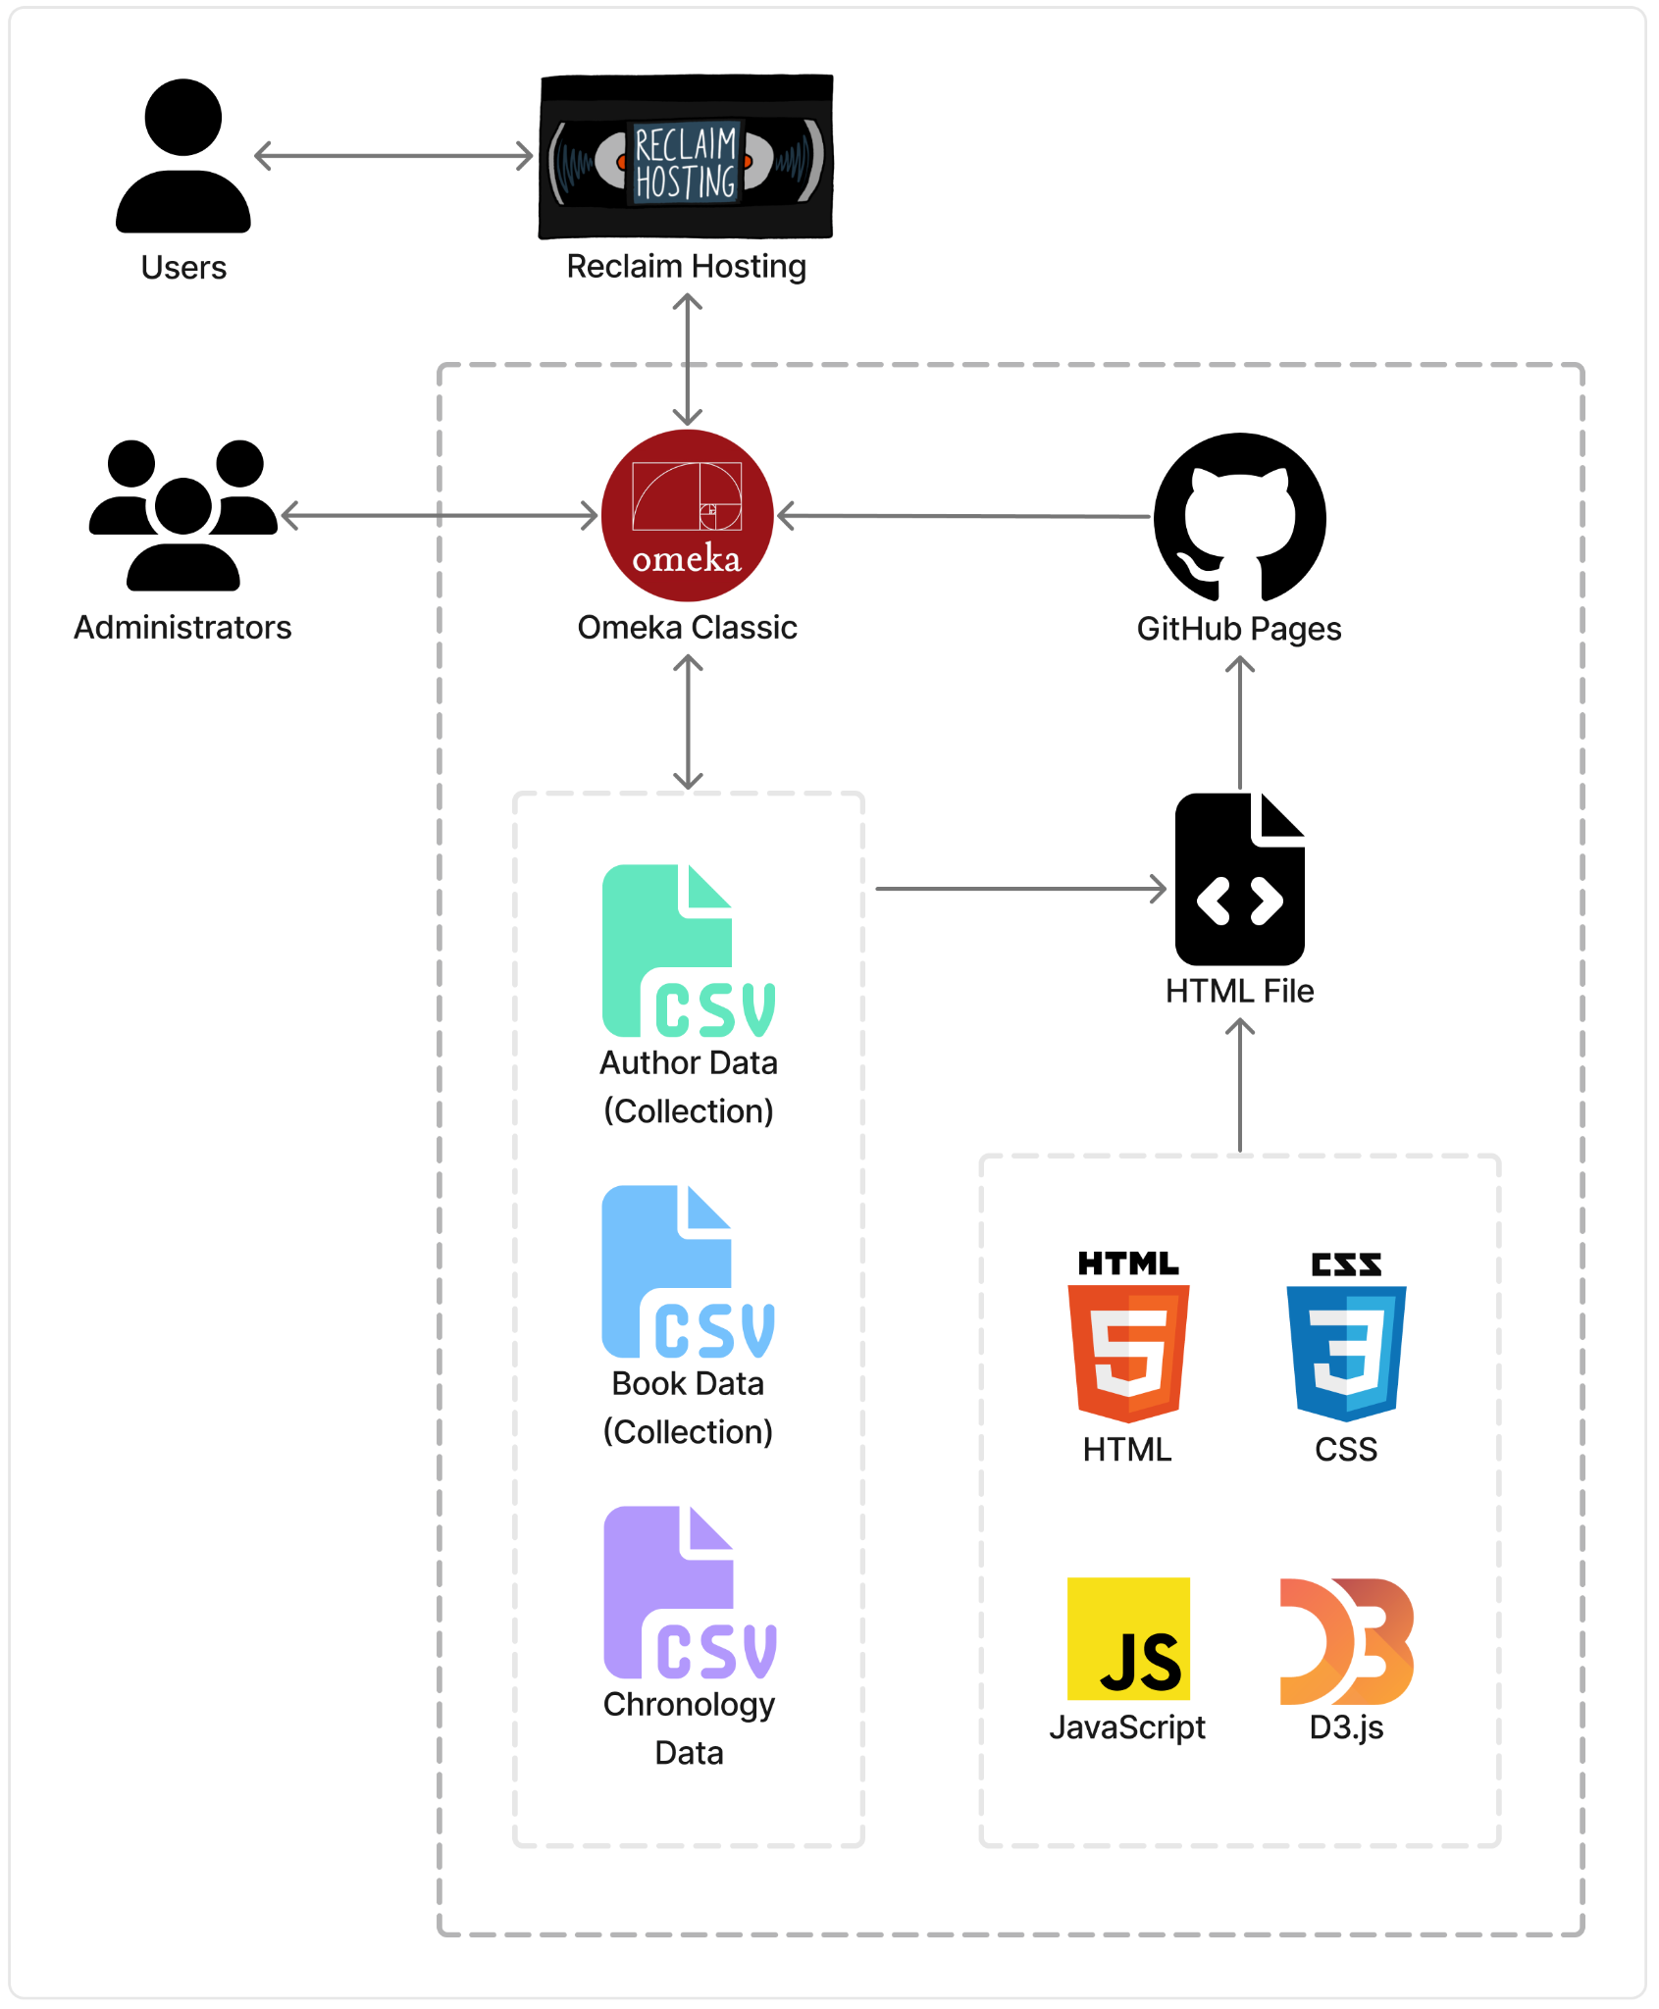

**Figure 1. Architecture Diagram: Technology Flow Chart**

## **Structure**

A team of researchers has been collecting and refining the Alabama Author dataset, bringing the number of author entries to over 1,700. Most of the data used within the project originates from this document. Currently, the data is stored in a spreadsheet on Auburn Box.

The original collection of data contains the following fields:

* Author_Last_Name_First_Name: “Last name, first name” (all caps)
* Author_Portrait_Link: Link to author image on Auburn Box
* Author_First_Name_Last_Name: “First name last name”
* Author_Pseudonym_Name: “Pseudonym”
* Author_Dates: Author lifespan, “Birth year-death year”
* City: Associated city
* County: Associated county
* Place_Of_Education: Associated education location
* Birth_Place: Associated place of birth
* Adult_Residence: Associated location of adult residence
* Place_Of_Death: Associated place of death
* Author_Biography: Short author description/biography
* Source: Referenced source(s)
* Book_Publications: Published books
* Book_Publications_Post_2000: Published works after 2000
* Other_Publications: Any other published works

The following fields were added to facilitate chronology data visualizations:

* Birth_Date: Birth year, extracted from Author_Dates
* Death_Date: Death year, extracted from Author_Dates
* Lifespan: Years lived, calculated from Birth_Date and Death_Date
* Author_First_Name_Last_Name_Author_Dates: Display name, created by concatenating Author_First_Name_Last_Name and Author_Dates
* New_Date: Author_Dates in a new format, including January 1 as placeholder month and day for each Birth_Date and Death_date, concatenated with a “/” between
* Page_Link: Link to author details page
* Image_Name: File name of author image

This spreadsheet can be converted into a comma-separated values (CSV) file for data processing. On Omeka Classic, data can be stored in collections, which utilize Dublin Core for categorization and organization across the site. Dublin Core defines metadata items within collections to assist in describing each field.

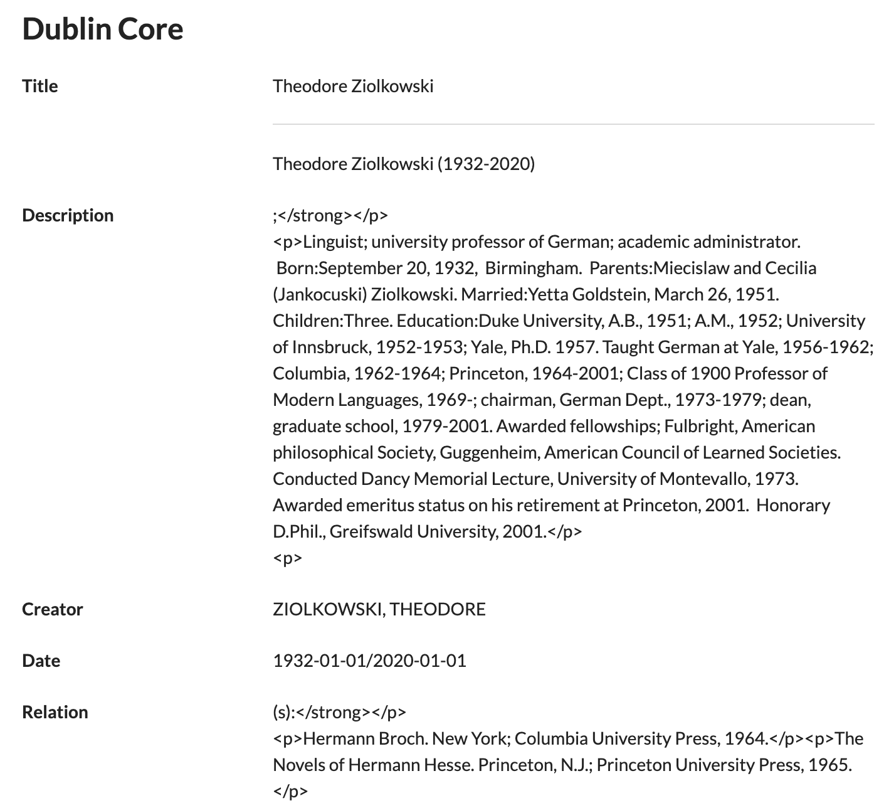

**Figure 2. Sample Author Dublin Core Metadata Fields**

Most of the data field to metadata category assignments are straightforward, but it can be beneficial to gain an understanding of the Dublin Core metadata definitions and intended usages. For this project, the identifier field is used to create relations between items, so the team was advised to refrain from utilizing this metadata attribute. Two of the Omeka Classic collections, the AL Author Collection and AL Book Collection, were exported to facilitate external data visualizations.

After attaching proper metadata tags to each data field, Omeka Classic stores the data in a collection. From a collection, author objects and respective attributes can be passed into internal pages and plugins. Collections can be displayed in a tabular format with sort features. Additionally, collections can be parsed within Omeka Classic plugins, which often provide data visualization capabilities. For external uses, the collections can be exported as CSV files and parsed using JavaScript to produce complex visualizations. These outside visualizations can then be hosted and incorporated back into Omeka Classic using an iframe embedding within a Simple Page or Exhibit.

The D3.js chronology visualization currently utilizes the following fields from the AL Author Collection:

* “Dublin Core:Title”: “First name last name”
* “Dublin Core:Date”: Author lifespan, “Birth year-death year”
* “Item URI”: Link to author details page
* “file”: Array of links to author images hosted on Omeka Classic

The D3.js sunburst visualization currently utilizes the following fields from the AL Author Collection and Book Publication Collection:

* AL Author Collection
  + “Dublin Core:Title”: “First name last name”
  + “Dublin Core:Date”: Author lifespan, “Birth year-death year”
  + “Item URI”: Link to author details page
  + “file”: Array of links to author images hosted on Omeka Classic
* Book Publication Collection
  + “Dublin Core:Title”: “Book Title”
  + “Dublin Core:Date”: Book publication date
  + “Item URI”: Link to book details page
  + “file”: Link to book cover image hosted on Omeka Classic

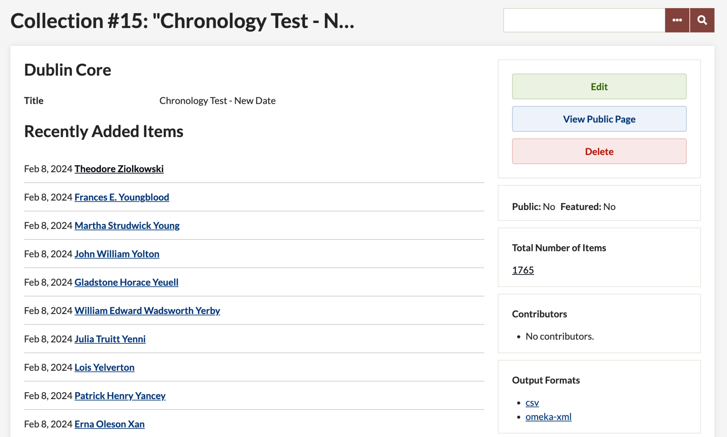

**Figure 3. Chronology Test Collection on Omeka Classic**

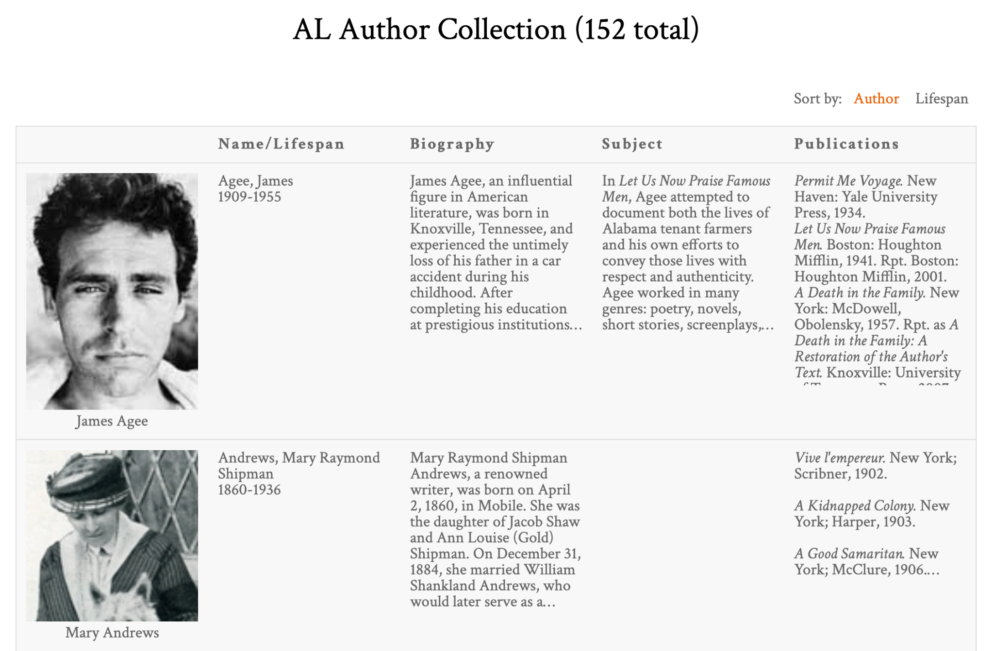

**Figure 4. Alabama Author Collection on Page with Tabular Format**

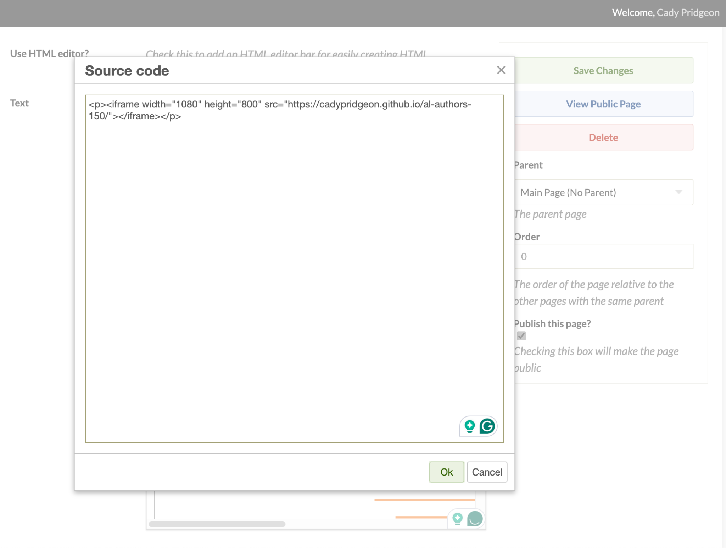

**Figure 5. Alabama Author Simple Page Iframe Embedding**

## **Interfaces**

Omeka Classic allows the use of supported plugins to facilitate data parsing and visualization on a website. During team research, the following plugins were identified as possible means by which a chronology could be created within Omeka Classic:

* Neatline Time
* Timeline
* Neatline

The Neatline Time plugin provides a very basic interface, displaying thin bars for each author instance on the timeline. The time axis can be centered on a specified date, but it cannot be specified any further. Due to this constraint, navigation of the visualization may cause user frustration. The plugin maintains a granular view of the data, which minimizes the impact of the number of author data entries collected. It provides basic author information, such as author name, lifespan, description, and link. Thus, it provides no unique functionality that sets it apart from similar plugins.

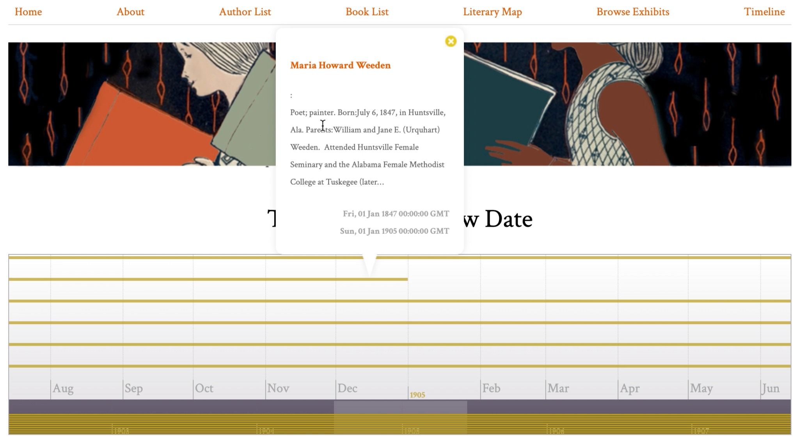

**Figure 6. Omeka Classic Neatline Time Plugin Chronology Visualization**

The Timeline plugin provides an interesting interface. The timeline portion of the visualization resembles the Neatline Time plugin, but it does provide more functionality. It has four navigation help options, including zoom in, zoom out, jump to front, and jump to back. Additionally, when a user clicks on an author span, instead of populating a tooltip, the author information shows in the space above the timeline. This allows for increased focus on the author, as well as more room for detailed information. The plugin also contains arrows at the top, allowing for navigation to the next or previous author, based on birth year. However, the primary drawback to this plugin is its latency. This plugin is the slowest of the three due to its navigation features.

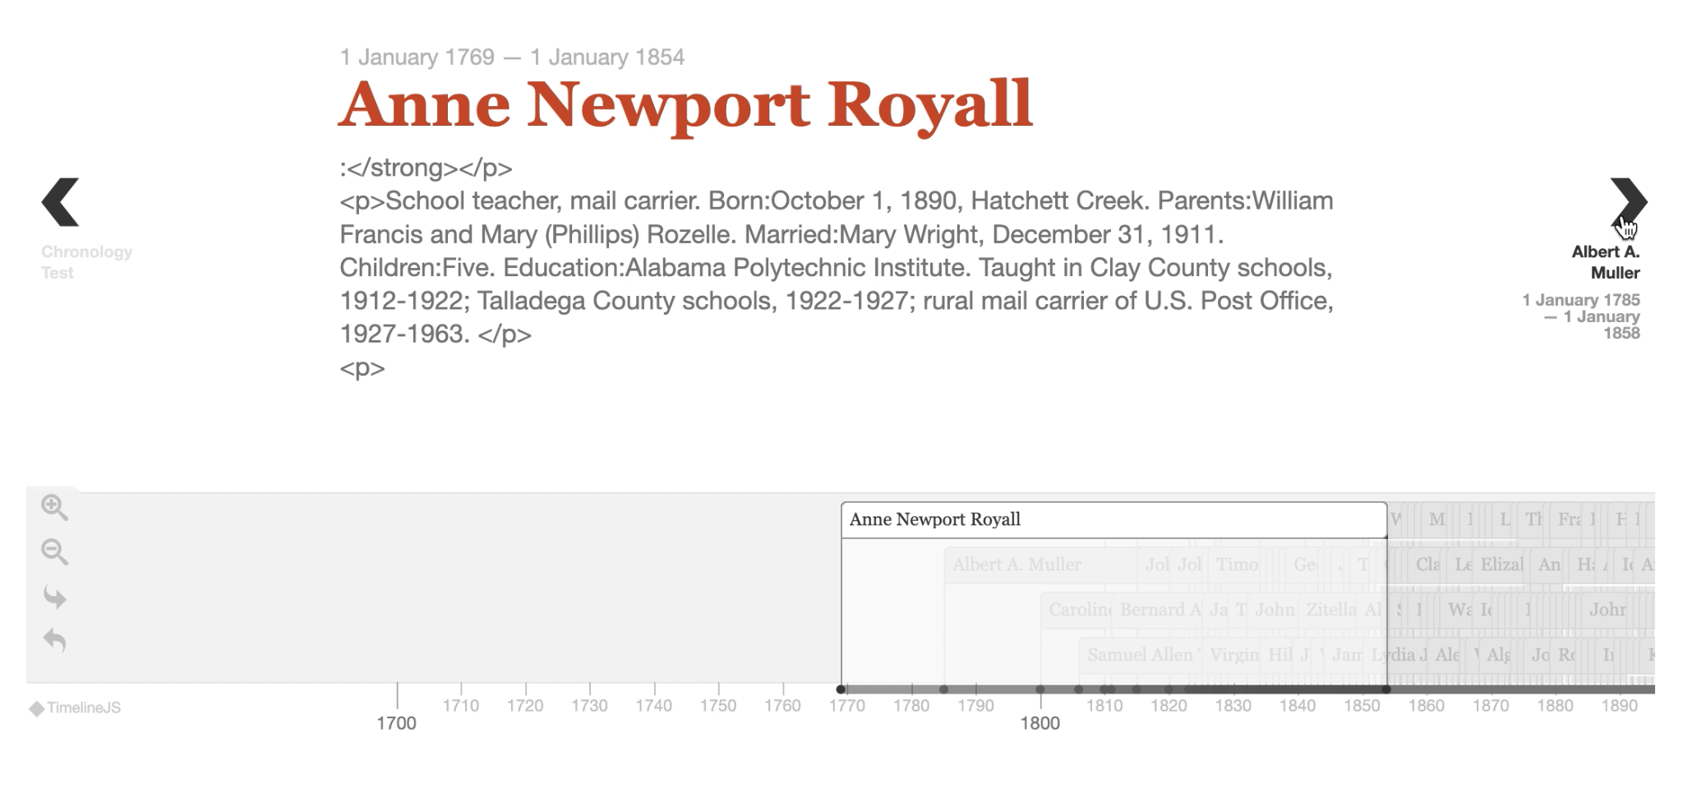

**Figure 7. Omeka Classic Timeline Plugin Chronology Visualization**

The Neatline plugin provides more functionality within its interface, allowing users to click on a predefined area of an image to zoom in and explore. It is currently used for the Literary Map on the Alabama Authors website because of this feature. When clicking on authors, the information listed is customizable, allowing for increased specification of the system. A heatmap-style solution was proposed, since a sunburst chart may best complement the plugin’s image support. With its increased interactivity and personalization, it seems promising for the chronology. However, all information available on the visualization must be entered manually. This includes any author information, such as their image and link, and developers would have to manually activate the SIMILE Waypoints Timeline widget for each entry.

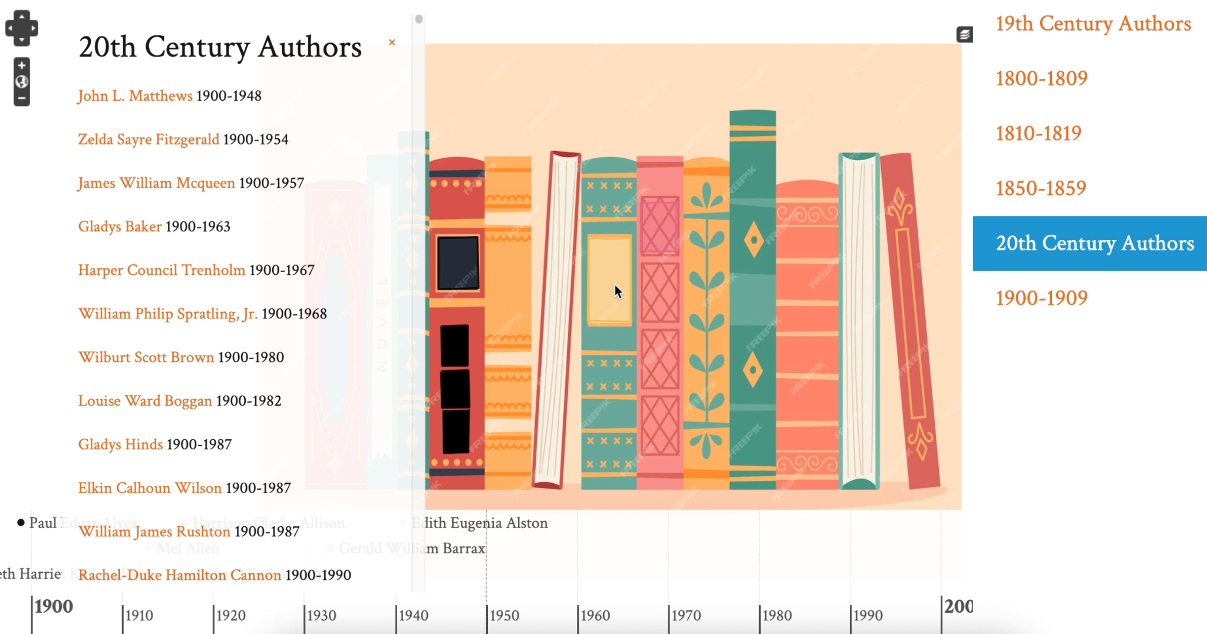

**Figure 8. Omeka Classic Neatline Plugin Chronology Visualization**

Two additional plugins, AvantRelationships and Archiviz, were identified for possible data visualization in a graphical format. If time permits, these could be interesting visualization options to increase data exploration capabilities.

One external data visualization tool was explored for experimentation purposes. The project sponsor expressed interest in seeing robust and interactive visualizations, even if they needed to be hosted externally and interfaced with Omeka Classic. The team decided to investigate D3.js, a JavaScript library for creating interactive data visualizations. The D3.js chronology visualization is in a zoomable bar chart style, with author information on a hover state, clickable bars, filter functionality, and sort functionality. Currently, the visualization interfaces with Omeka Classic through an iframe embedding within a Simple Page, but it could be possible to host the visualization on Reclaim Hosting if necessary.

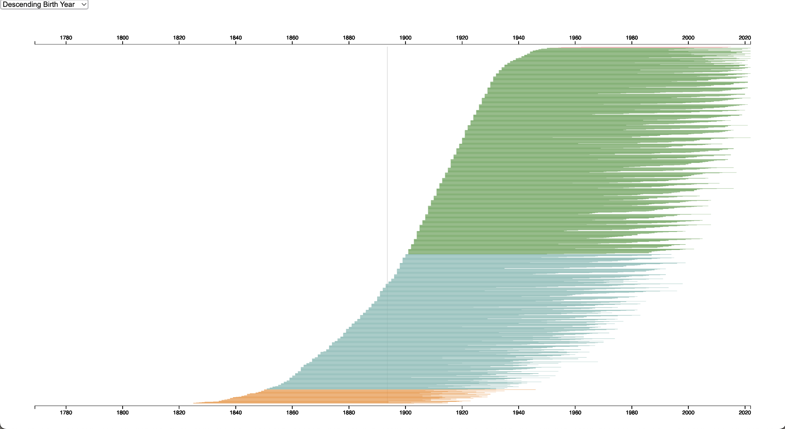

**Figure 9. Initial D3.js Bar Chart Chronology Visualization**

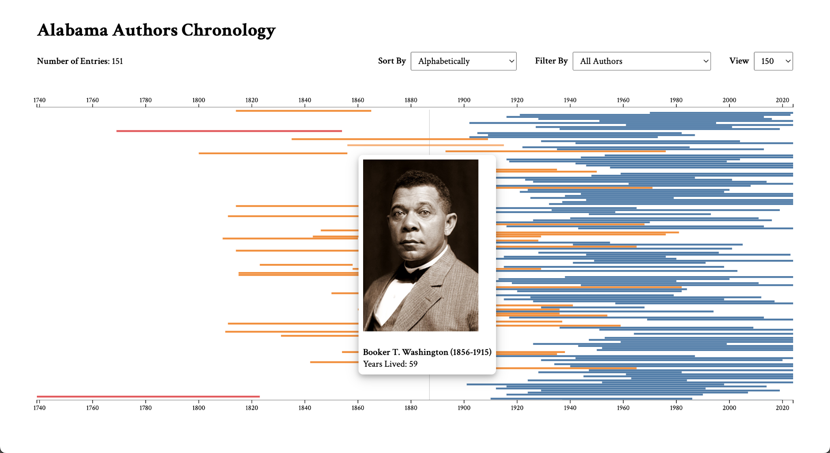

**Figure 10. Current D3.js Bar Chart Chronology Visualization**

The team created an additional D3.js visualization with zoomable sunburst capabilities. This visualization bridges the gap between the chronology and book publication sunburst wheel by allowing users to select authors and see their book publications together. Similarly to the chronology, the sunburst visualization is clickable and zoomable, displays author and book information on a hover state, and supports export functionality. It also currently interfaces with Omeka Classic through an iframe embedding on the Simple Page plugin. The team discussed putting this tool on Reclaim Hosting, but due to the evolving nature of the project, this integration is being pushed back for now.

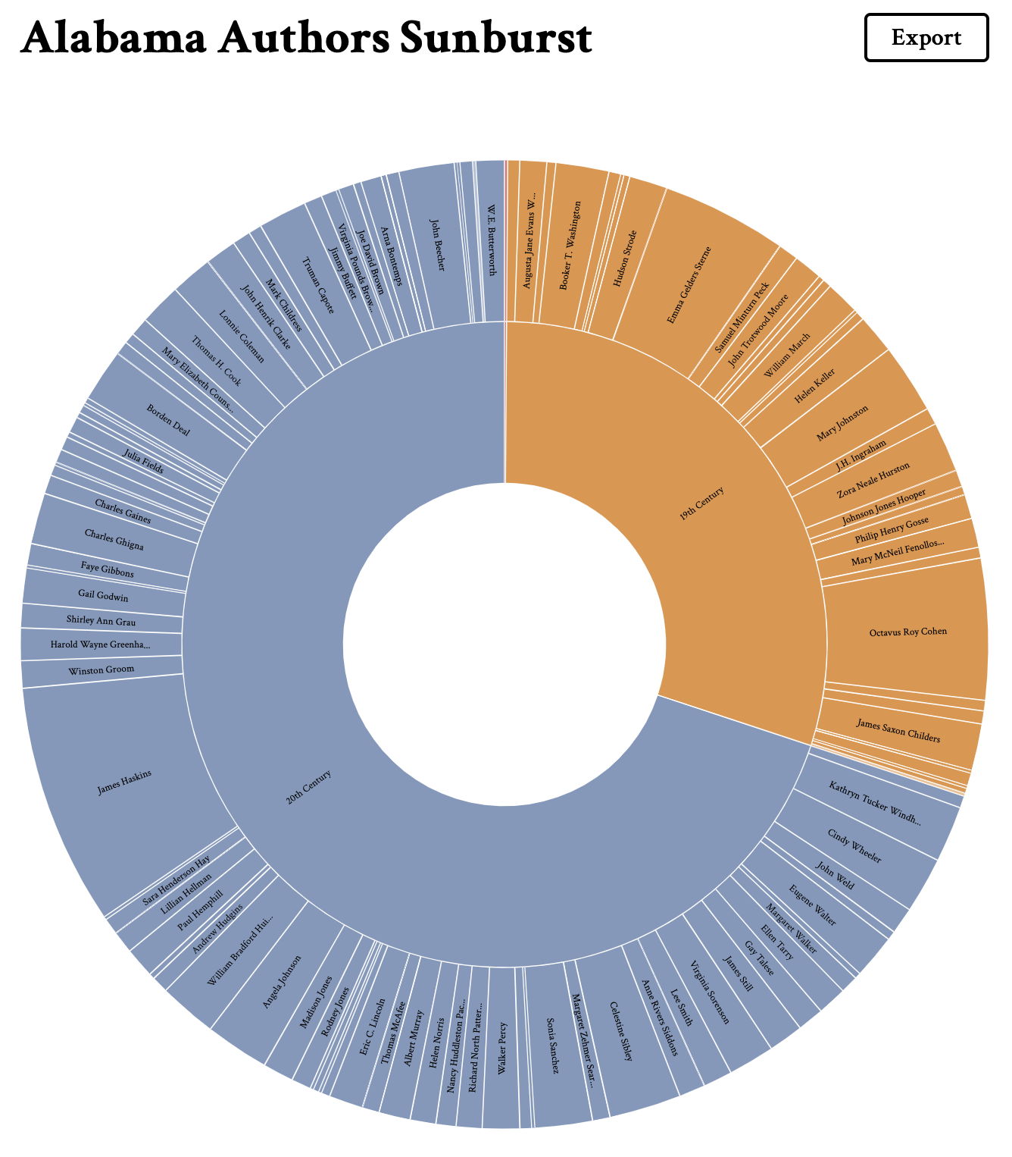

**Figure 11. Current D3.js Sunburst Visualization**

## **Justifications of Decisions**

Most of the project design decisions were previously established. Omeka Classic and Reclaim Hosting have been used for prior projects, so the project sponsor required that the team utilize this architecture for Alabama Authors.

During the initial meeting, the sponsor advised against hosting visualizations on GitHub repositories and displaying them on the website using an iframe. This solution was suggested to be avoided since it causes permissions and security issues for administrators. Thus, the team initially decided to move forward with plugins supported internally within Omeka Classic.

However, these plugins provided rudimentary functionality, so with sponsor approval, the team decided to explore an external option. Since D3.js provided the functionality the team’s sponsor was looking for, the iframe embedding solution was enthusiastically supported by the project sponsor. Both the Neatline plugin and D3.js solutions were pursued by the project to provide greater flexibility and user control over preferred visualizations.

Storing the external code on Reclaim Hosting is an option that was discussed between the sponsor, project technical lead, and team, but it was decided to hold off on incorporating the code with the hosting site. Since additional graduate students are working on visualizations for the website, there may be changes to data or the visualizations themselves that may be worth waiting for before uploading to the hosting service. However, to ensure a smooth transition, the code is optimized for simple hosting. All of the code is in one index.html file, and the majority of the data being used is standardized through Omeka Classic. Any data not on Omeka Classic has been uploaded to the Alabama Authors Box repository and also shared directly with the sponsor.

## **Assumptions & Dependencies**

This project assumes that the primary data sources are the Alabama Authors CSV file, AL Author Collection CSV file, and AL Book Collection CSV file. Utilizing exported collection data can facilitate greater consistency between the website data and visualization data, so the team shifted towards more heavily relying on the collection data.

The capabilities of the chronology visualization depend on the flexibility and comprehensiveness of the plugins available on Omeka Classic. Since the sponsors initially advised avoiding creating a visualization hosted on GitHub, the team was limited to the capabilities available on Omeka Classic. Now, as the sponsors determined that hosting on GitHub is acceptable, the team was able to move forward with the D3.js solution. However, keeping security and permission concerns in mind, this external solution may not be optimal in the long-term scope of the project.

All of the visualizations are available on the Alabama Authors website through Omeka Classic. The Neatline visualization can be edited straight through the Exhibit Builder or the Neatline plugin page. The external D3.js visualizations are located on GitHub under the Alabama Authors organization. These tools rely on the functionality of the Neatline plugin and GitHub pages, but the sponsor has complete access and control of these sources for simplified administration going forward.

# **Setup**

## **Omeka Classic**

To begin working on the project, access to Omeka Classic is necessary. To gain access to the Alabama Authors Omeka Classic administrator dashboard, please contact Dr. Beverly Rilett at [bdr0032@auburn.edu](mailto:bdr0032@auburn.edu).

After setting up an Omeka Classic administrator account, developers can access the data collections, Neatline exhibits, and Simple Pages where the current visualizations reside.

## **GitHub**

Developers will need a GitHub account to contribute to the Alabama Authors organization on GitHub. Dr. Rilett prefers that all her project code be accessible from one place, so editing previous projects will be done from the Alabama Authors GitHub organization. The D3.js chronology visualization repositories are available on the organization page. If creating a new visualization, clone the repository to the organization for future access and management.

# **Testing**

## **Testing Plan**

Since this project is visualization-based, the team decided to pursue a manual testing method. Team members think of nominal cases and edge cases to test visualizations with. The team will then record test action steps, expected results, and actual results to determine the test result. After receiving the results, the team will pursue the next steps accordingly.

This visual approach to testing may not guarantee that the code is completely free of bugs, but it does confirm that the functionality of the visualization is up to standards. Especially within the Omeka Classic system, generating automatic, code-based tests is not practical for this project.

## **Test Cases & Results**

To view the team’s previous acceptance and usability tests for the three data visualizations, please view the Cycle 3 Report Testing Documentation section at <https://docs.google.com/document/d/1eKfcqv3jNrY_rTyrd-PwzMrfLB6uC6f_f06i9J7A0Sc/edit?usp=sharing>.

# **Deployment**

## **Omeka Classic**

If utilizing a Neatline plugin within Omeka Classic, deployment is straightforward. The Neatline plugin will have an associated Exhibit, in which the plugin page can be made public by editing its settings.

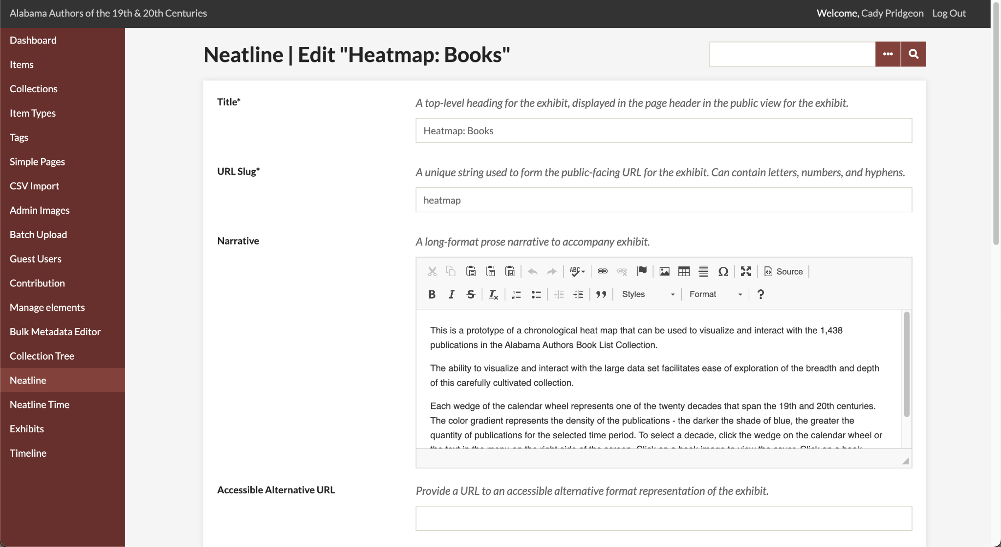

**Figure 12. Neatline Heatmap Exhibit Settings**

If connecting an existing GitHub Pages URL to Omeka Classic, developers will need to use the Simple Pages plugin for Omeka Classic. After creating a new Simple Page, developers can add an iframe embedding for the GitHub Page URL and then publish the Simple Page from its settings.

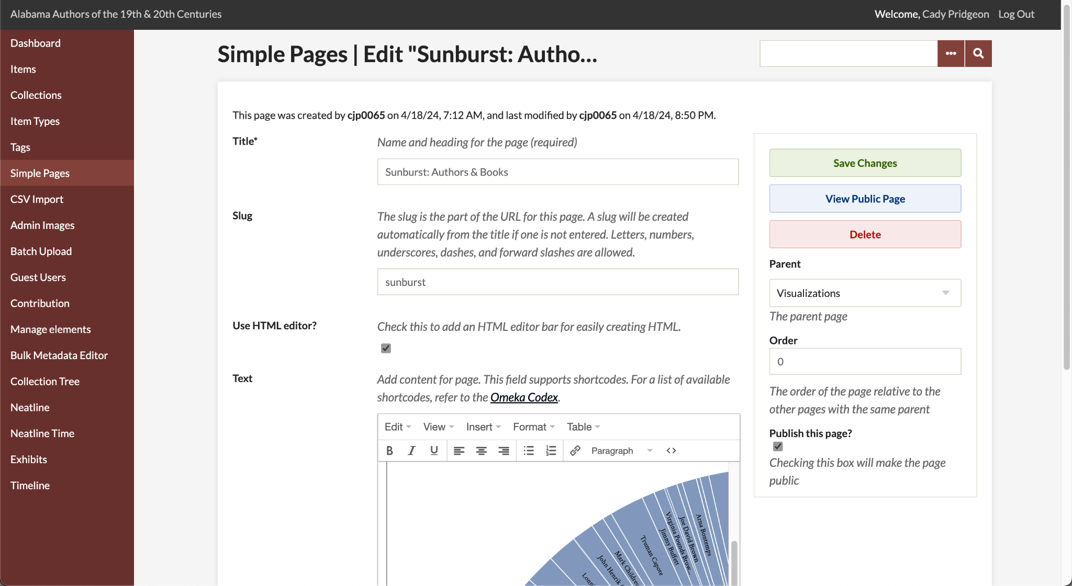

**Figure 13. D3.js Sunburst Simple Page Settings**

## **GitHub Pages**

To use GitHub Pages to publish a visualization, utilize GitHub actions. If the website is static, developers can enable the GitHub Page from the repository settings. However, if the website is dynamic, a similar approach can be taken while enabling GitHub Actions to repetitively update website data.

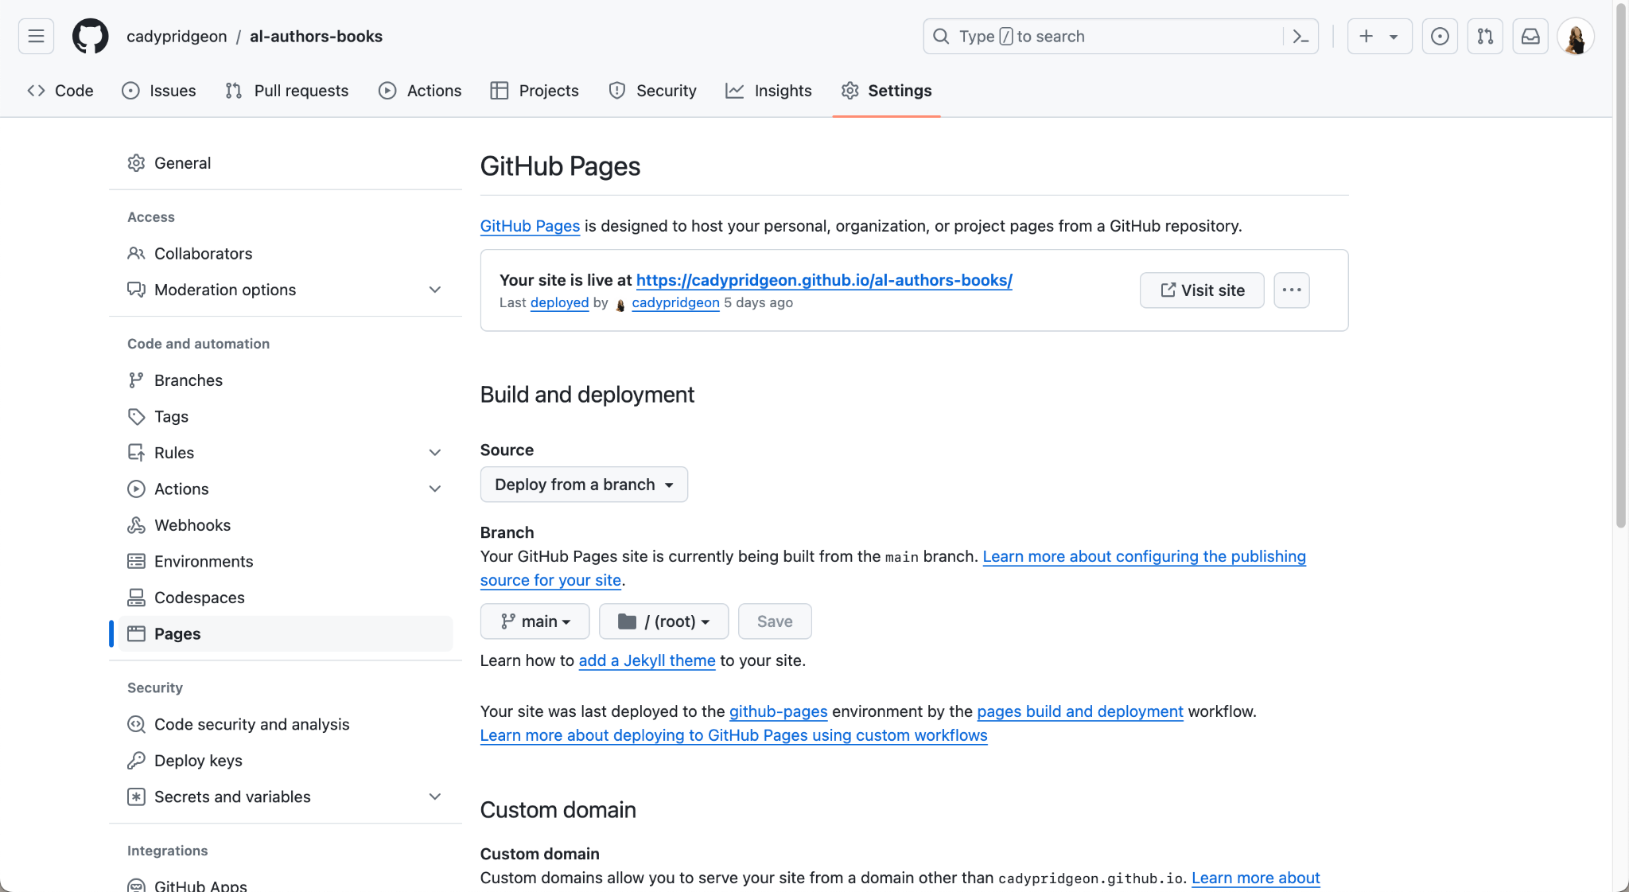

**Figure 14. D3.js Sunburst GitHub Pages Settings**

# **Version History**

## **Neatline**

**Version 2.0**

For the current solution on Omeka Classic, the Neatline plugin offers a timeline and chart wheel heatmap for data interaction.

Key Features:

* Neatline timeline functionality for viewing authors
* Neatline heatmap functionality for viewing author density on a calendar wheel
* Book publication support

Bugs & Issues:

* Neatline requires tedious manual data entry that remains in progress

**Version 1.0**

For the current solution on Omeka Classic, the Neatline, Neatline Time, and Timeline plugins offer three various timeline visualizations of the complete Alabama Authors data.

Key Features:

* Neatline functionality for viewing authors by period
* Neatline functionality for viewing author name, lifespan, photo, and details page from the visualization
* Neatline Time and Timeline secondary functionality available

Bugs & Issues:

* Neatline Time and Timeline produce slow and limited visualizations
* Neatline uses a placeholder image for now
* Neatline requires manual data entry

## **D3.js**

**Version 3.0**

In the last release of this product, there are two D3.js visualizations available. One is a chronology that processes the complete Alabama Authors data and the Alabama Authors Collection data in an interactive format. The other is a sunburst that connects the Alabama Authors Collection data and the Alabama Book Publications data.

Key Features:

* Chronology
  + Zoomable chart to highlight the magnitude of data
  + Hover states available for additional author information
  + Provides sort and filter capabilities to customize data shown
  + Allows users to switch between the complete author data and collection data with the view dropdown
  + Uses color-blind-friendly colors
  + Produces an interesting and modern visualization that is consistent with the Alabama Authors website branding
  + Available on the Alabama Authors website
  + Responsive for mobile and desktop devices
  + Accessible with keyboard tabbing
* Sunburst
  + Interactive sunburst to bridge the author and book collection data
  + Hover states available for additional author and book information
  + Provides export capabilities for straightforward visualization downloading
  + Uses color-blind-friendly colors
  + Produces an interesting and modern visualization that is consistent with the Alabama Authors website branding
  + Available on the Alabama Authors website
  + Responsive for mobile and desktop devices
  + Accessible with keyboard tabbing

Bugs & Issues:

* Chronology
  + The tooltip does not show when using keyboard navigation
* Sunburst
  + The tab order is not entirely correct due to the data processing order
  + You cannot directly go to detail pages using tab navigation

**Version 2.0**

For the current solution using D3.js, the visualization processes the complete Alabama Authors data and the Alabama Authors Collection data in an interactive format.

Key Features:

* Zoomable chart to highlight the magnitude of data
* Hover states available for additional author information
* Provides sort and filter capabilities to customize data shown
* Allows users to switch between the complete author data and collection data with the view dropdown
* Uses color-blind-friendly colors
* Produces an interesting and modern visualization that is consistent with the Alabama Authors website branding
* Available on the Alabama Authors website

Bugs & Issues:

* The visualization is not yet responsive for mobile devices
* Accessibility features need to be implemented

**Version 1.0**

For the current solution using D3.js, the visualization processes the complete Alabama Authors data in an interactive format.

Key Features:

* Zoomable chart to highlight the magnitude of data
* Hover states available for additional author information
* Produces an interesting and modern visualization that is sortable

Bugs & Issues:

* Does not interface with the Omeka Classic system
* Some sort functionality is not bug-free
* Photos and detail links require manual data entry

# 

# **References**

Cady Pridgeon, Amee Kivette, Keanna Tennyson, and Laura Wilson. 2024. *Visualization: Architectural Spike*. COMP 4710 Senior Design Project 3 Team Orange Architectural Spike Written Report. Auburn University, Auburn, AL.

Cady Pridgeon, Amee Kivette, Keanna Tennyson, and Laura Wilson. 2024. *Visualization: Cycle 1*. COMP 4710 Senior Design Project 3 Team Orange Cycle 1 Written Report. Auburn University, Auburn, AL.

Cady Pridgeon, Amee Kivette, Keanna Tennyson, and Laura Wilson. 2024. *Visualization: Cycle 2*. COMP 4710 Senior Design Project 3 Team Orange Cycle 2 Written Report. Auburn University, Auburn, AL.

Cady Pridgeon, Amee Kivette, Keanna Tennyson, and Laura Wilson. 2024. *Visualization: Cycle 3*. COMP 4710 Senior Design Project 3 Team Orange Cycle 3 Written Report. Auburn University, Auburn, AL.